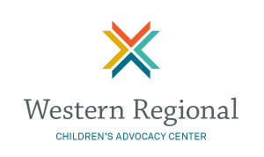

October 8, 2019
Boise, ID

Facilitator: Patty Terzian, State Liaison, WRCAC and
Salli Kerr, State Liaison, WRCAC

TRAINING OBJECTIVES

- Define the purpose and value of multidisciplinary collaboration in the investigation, prosecution and treatment of child abuse
- Identify common challenges of an MDT
- Identify dynamics of effective MDTs
- Recognize the impact of traumatic stress on MDT members and identify strategies to build resiliency

8:00 – 8:45 Registration and light refreshments

9:00 – 9:30 Welcome and Introductions
& Award of Excellence

9:30 – 10:00 Idaho MDTs

10:00 – 10:45 Understanding the Multi-Disciplinary Team

10:45 – 11:00 Break

11:00 – 12:00 Building Stronger Multi-Disciplinary Teams: A View from the Research

12:00 – 1:15 Lunch – MDT Mock Case Review

1:15 – 2:15 Current and Future Response to Child Abuse

2:15 – 2:45 CFR Team Report

2:45 – 3:00 BREAK

3:00 – 4:30 Building Resiliency in CACs and MDT Professionals

